1. **Write a Python program to Extract Unique values dictionary values?**

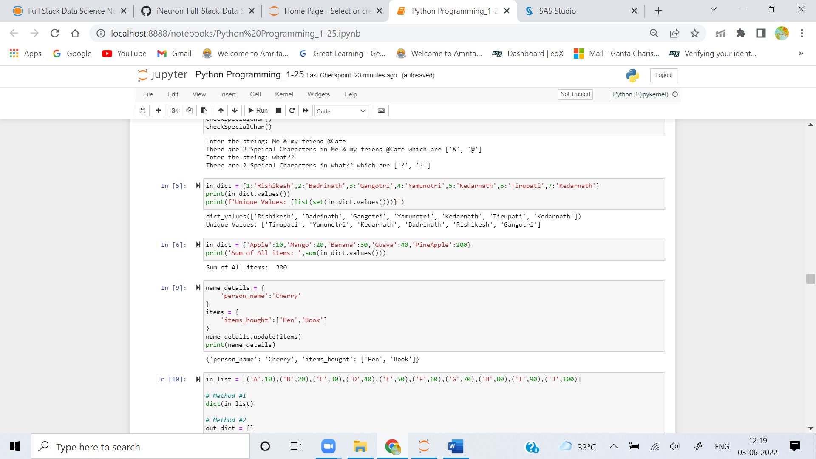

1. **Write a Python program to find the sum of all items in a dictionary?**



1. **Write a Python program to Merging two Dictionaries?**



1. **Write a Python program to convert key-values list to flat dictionary?**

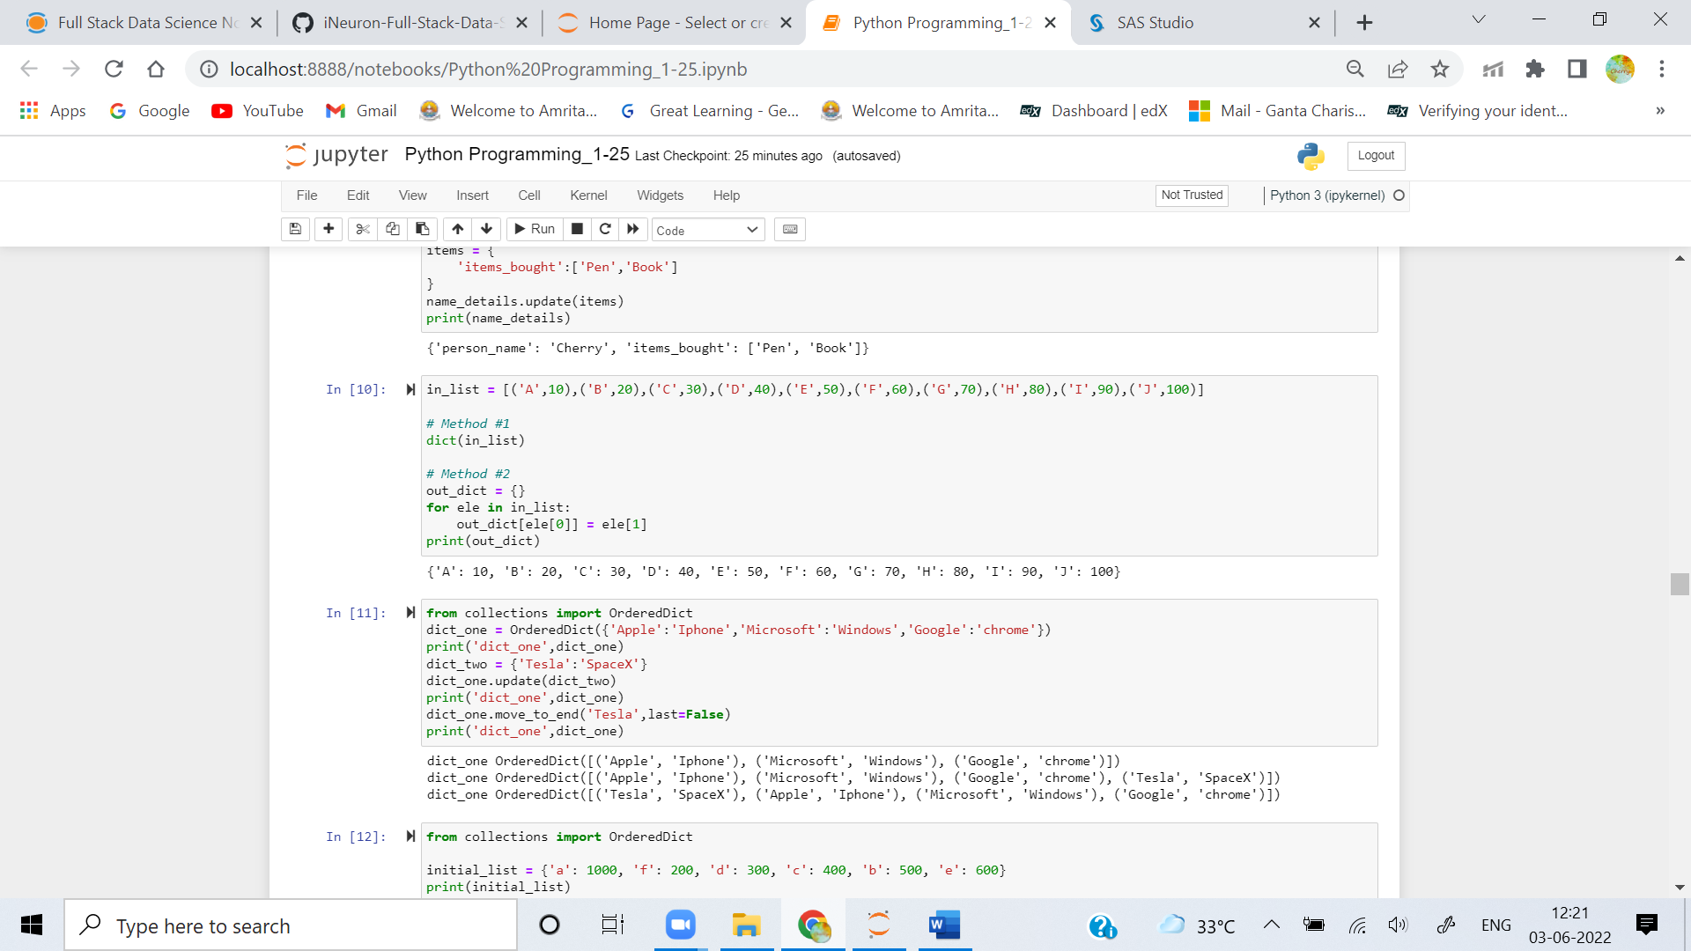

1. **Write a Python program to insertion at the beginning in OrderedDict?**



1. **Write a Python program to check order of character in string using OrderedDict()?**

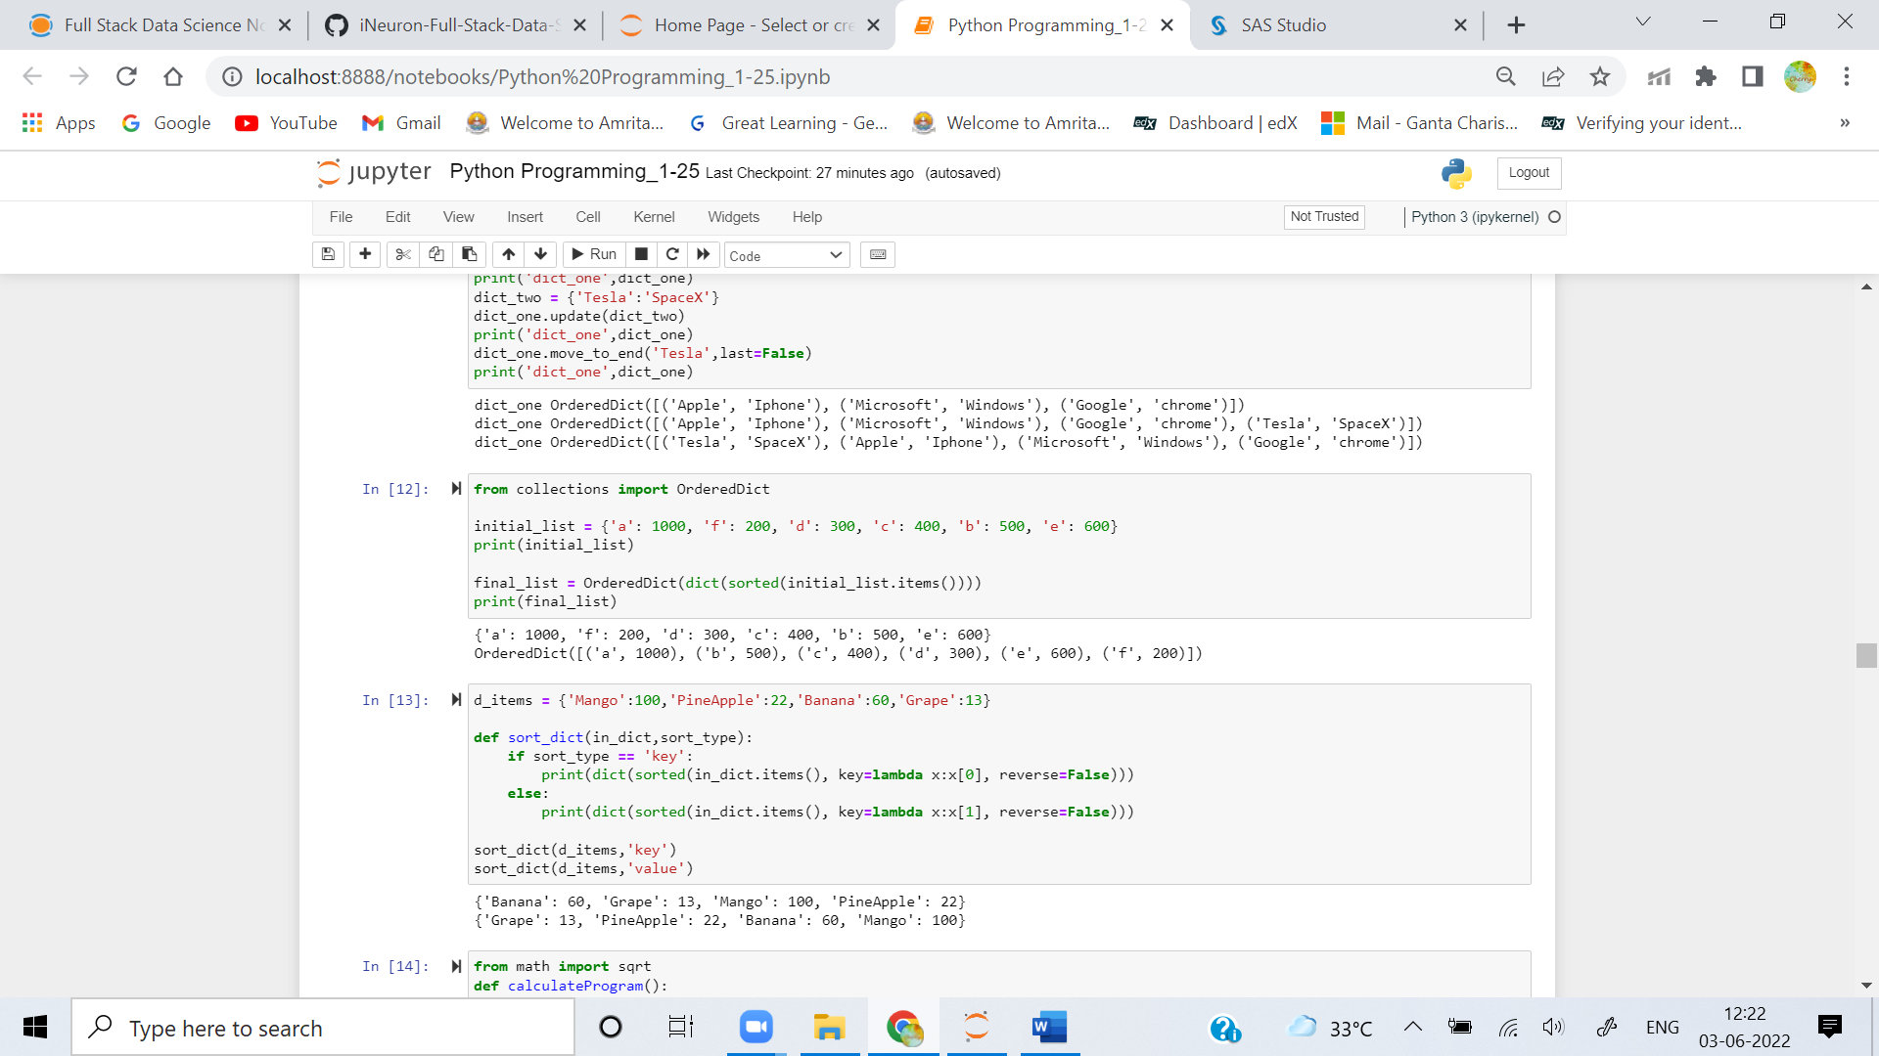

1. **Write a Python program to sort Python Dictionaries by Key or Value?**

